The Step-by-Step Process of Getting a Dental X-ray (OPG) at Crystal Radiology. (02) 8897 8686

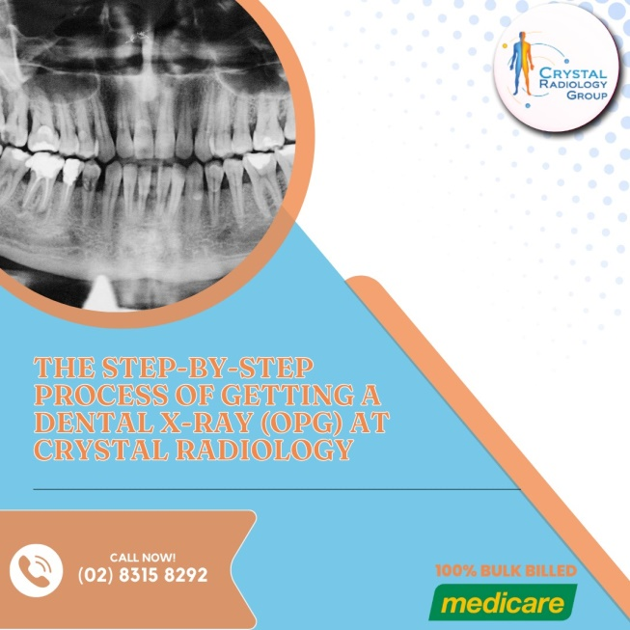Crystal Radiology is essential in diagnosing and monitoring various dental and orthodontic conditions. One commonly used dental radiographic procedure is the Orthopantomogram or OPG scan. This imaging technique offers a panoramic view of the entire mouth, including the teeth, jaws, and surrounding structures, which is invaluable for diagnosis and [treatment](https://crystalradiology.com.au/dental-xray-opg/) planning.

At Crystal Radiology, we take pride in offering high-quality Dental X-ray (OPG) to ensure patients receive the best possible care. This article will guide you through the step-by-step process of getting an OPG scan, from scheduling your appointment to receiving your results.

**Step 1: Schedule an Appointment**

The first step to getting an Dental X-ray (OPG)is to schedule an appointment with your dentist or directly with a dental imaging center like Crystal Radiology. It’s important to communicate your specific dental concerns or the reason for needing the scan so that your dentist or radiology team can tailor the appointment to your needs.

Dental X-ray (OPG) are commonly used for [diagnosing dental issues](https://crystalradiology.com.au/dental-xray-opg/), planning orthodontic treatments, evaluating the condition of wisdom teeth, and monitoring oral health over time. They are also an essential tool in assessing dental implants, jaw disorders, or injuries.

**Step 2: Preparation**

One of the benefits of an Dental X-ray (OPG)is that it typically requires little to no preparation. Unlike other medical imaging procedures, Dental X-ray (OPG) do not involve fasting, dietary restrictions, or the need for sedation. However, it is still a good idea to inform your dentist or the radiology team if you have any medical conditions or are taking any medications.

For women, it’s important to inform the radiologist or [technologist](https://crystalradiology.com.au/dental-xray-opg/) if you are pregnant or may be pregnant, as this can affect the timing of the procedure.

**Step 3: Arriving at the Dental Imaging Center**

When you arrive at Crystal Radiology or another dental imaging center, you’ll be greeted by our professional staff, who will guide you through the entire process. You may be asked to complete a brief medical history form if it’s your first visit.

Before starting the scan, you’ll be asked to remove any metal objects such as jewelry, eyeglasses, or hairpins, as these could interfere with the quality of the images. You will also be provided with a protective lead apron to wear, which shields the rest of your body from unnecessary radiation exposure.

**Step 4: Positioning for the Scan**

The OPG machine, also known as an orthopantomogram, is designed to capture a full panoramic view of your oral cavity. For the scan to be accurate, correct positioning is crucial. A radiologic technologist will assist you in getting into the proper position in front of the machine.

You will be asked to stand or sit upright with your chin resting on a small platform and to bite down gently on a plastic bitestick. This ensures that your [teeth, jaws](https://crystalradiology.com.au/dental-xray-opg/), and surrounding structures are properly aligned for the scan. The technologist will make adjustments to the height of the machine to accommodate your head’s position.

**Step 5: The Scan**

Once you are correctly positioned, the OPG machine will begin rotating around your head. As it rotates, it takes a series of X-ray images from different angles. You’ll need to remain still and avoid talking or swallowing during the brief scan to ensure clear and accurate images.

The scan itself is quick and painless, usually lasting less than a minute. The OPG machine emits a low dose of radiation, and the entire process is over before you know it.

**Step 6: Reviewing the Images**

After the scan is complete, the images are processed and reviewed by a dentist, oral surgeon, or radiologist. These images provide a clear, detailed view of your teeth, jaws, and the surrounding structures, which can help in [diagnosing](https://crystalradiology.com.au/dental-xray-opg/) various conditions like tooth decay, impacted teeth, infections, bone fractures, and cysts.

At Crystal Radiology, our skilled team of radiologists carefully examines the Dental X-ray (OPG)to provide an accurate diagnosis. The detailed panoramic images make it easier to identify dental issues that may not be visible through routine dental exams.

**Step 7: Discussion and Treatment Planning**

After the OPG images have been reviewed, your dentist or oral health specialist will discuss the results with you. If any dental problems are identified, your dentist will go over your treatment options, which could range from simple fillings to more complex procedures like orthodontics or oral surgery.

For patients undergoing orthodontic treatment, the [Dental X-ray](https://crystalradiology.com.au/dental-xray-opg/) (OPG)helps in determining the alignment of teeth and jaw positioning. For those needing dental implants, it helps evaluate the bone structure and plan the placement of implants.

**Step 8: Follow-Up Appointments**

Depending on the findings from the OPG scan, you may need to schedule follow-up appointments for further evaluation or treatment. In some cases, additional diagnostic tests may be recommended, especially if there are complex issues like impacted teeth or jawbone problems.

Routine Dental X-ray (OPG) might also be part of your regular dental check-ups, particularly if you are undergoing long-term dental or orthodontic treatment. These scans allow your dentist to monitor changes in your oral health over time and adjust treatment plans accordingly.

**Why Choose Crystal Radiology?**

We are local and a privately-owned medical clinics that offers the highest quality medical and Imaging Services in the [Crystal radiology](https://crystalradiology.com.au/appointment/) region. We are the leaders in Bulk Billing with the real benefit of no ‘Out of Pocket’ expenses for you.

**Your Next Step**

Please ensure that you have your Medicare card and referral with you and pop into our location for your consultation. If you have any questions at all, please feel free to contact us at [(02) 8315 8292](https://crystalradiology.com.au/appointment/) as we are here to help.